Environment_Build_up

1. Java JRE/JDK:

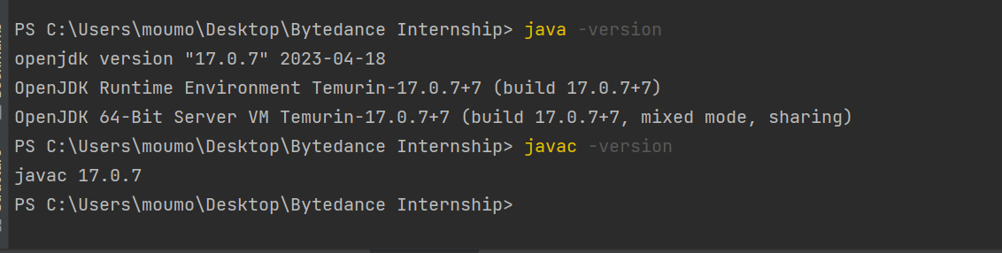

1. JetBrains IDEA Community:

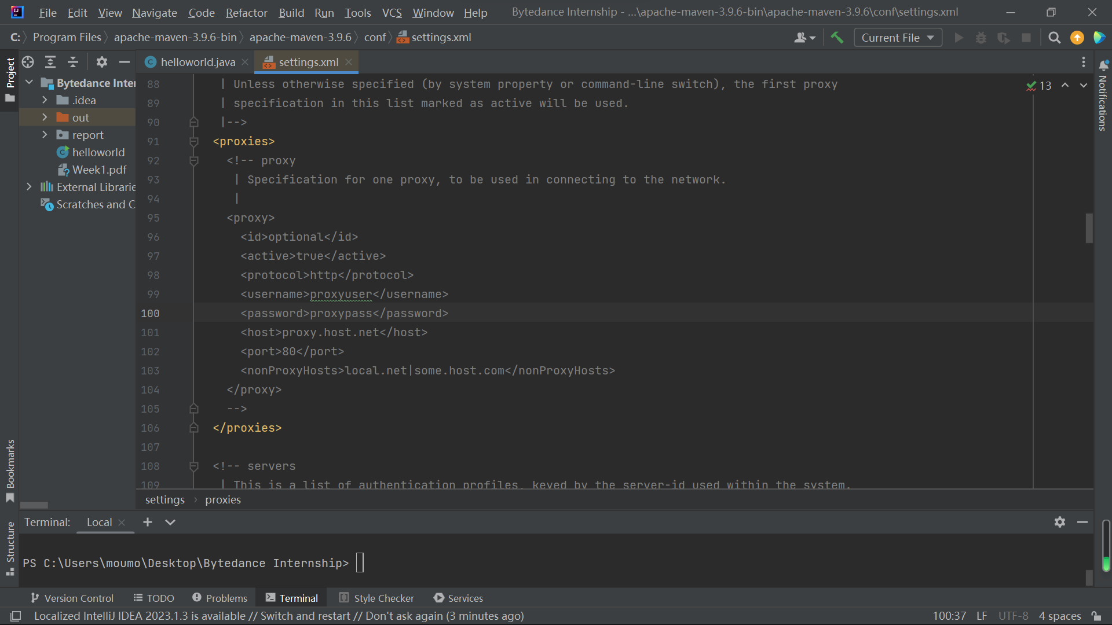

1. Maven:

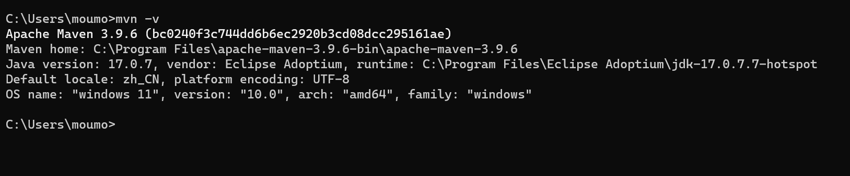

1. MySQL:

cmd界面:

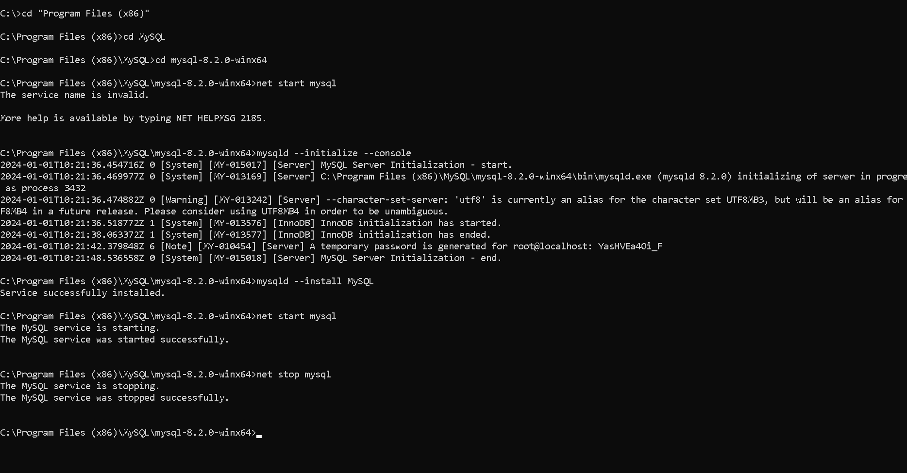 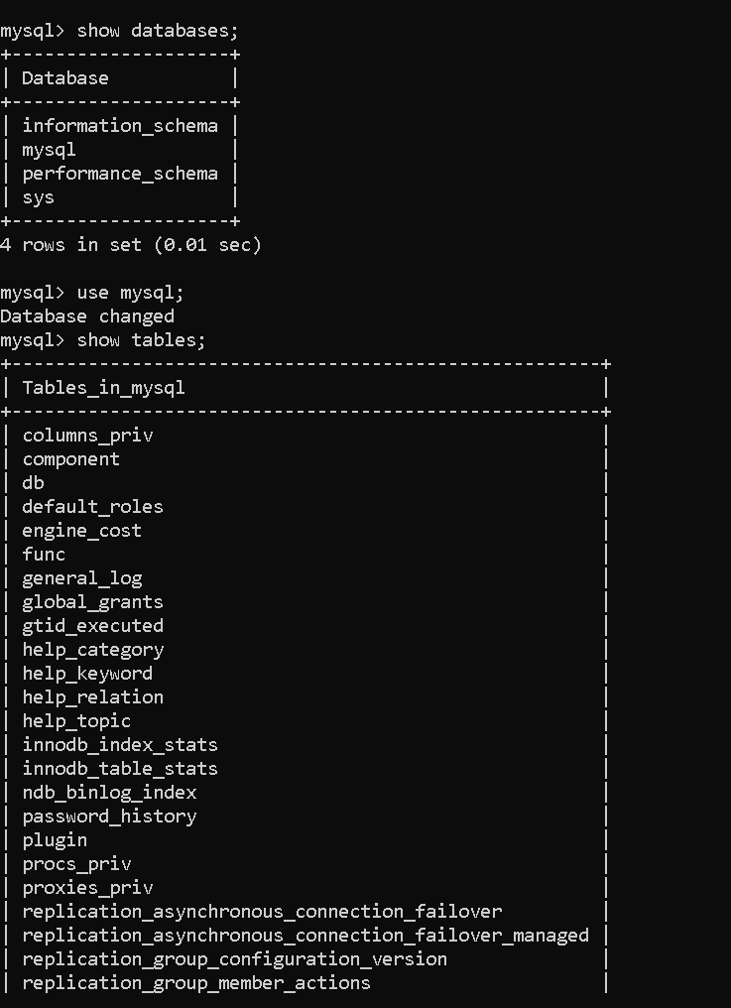

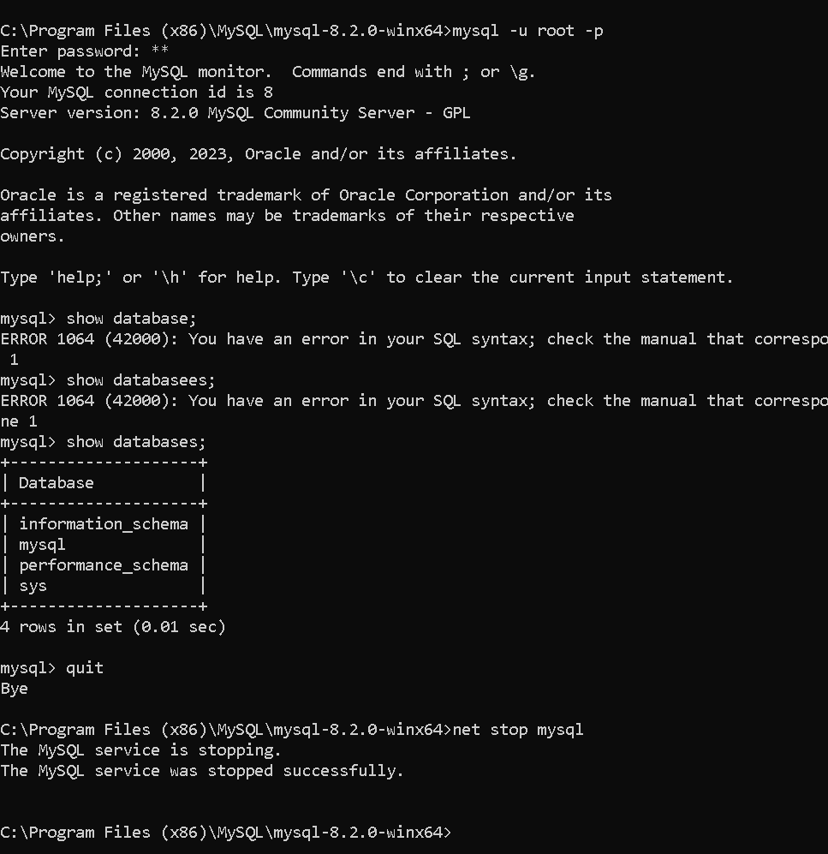

图形界面 HeidiSQL:

